MCj03358800000[1] Circulatory System Worksheet #1 MCj03358800000[1]

Biology

Name ______________________________________________________ Date _______________

Read the textbook pages 943-950. Then use the information in the textbook and your class notes to answer the following questions.

1. The heart is enclosed in a protective sac of tissue called the _____________________________.

2. The heart beats on average _______ times a minute, and pumps about _______________ liters of blood a day through the pathway.

1. What is the difference between pulmonary and systemic circulation?
2. The pacemaker system of the heart is controlled by 2 different sets of cells. What are the names of these pacemaker cells, and where are they located?
3. Explain the differences between arteries, veins, and capillaries. Discuss structure and function (jobs).

Arteries -

Veins –

Capillaries -

1. a. What is blood pressure?

b. What is the technical name of the device that measures blood pressure?

c. How is blood pressure regulated/controlled?

1. What are the major differences between the right and left sides of the heart? Discuss type of blood and where the blood is pumped to.

9. What is the name of the only artery to carry blood with no oxygen?

9. a. What is atherosclerosis?

b. What happens if atherosclerosis causes one of the heart’s arteries to become blocked?

10. What is high blood pressure? Why is high blood pressure dangerous?

MCj03358800000[1] Circulatory System Worksheet #2 MCj03358800000[1]

Name ______________________________________________________ Date _______________

Read the textbook pages 951-955. Then use the information in the textbook and your class notes to answer the following questions.

1. Explain in detail the jobs of the **four** parts of blood listed below.

Plasma –

Red blood cells –

White blood cells –

Platelets –

2. Explain the process that occurs when platelets work to form a blood clot.

3. What is the job of the lymphatic system?

4. What are the jobs of lymph nodes?

5. In the space below label the diagram of the heart.

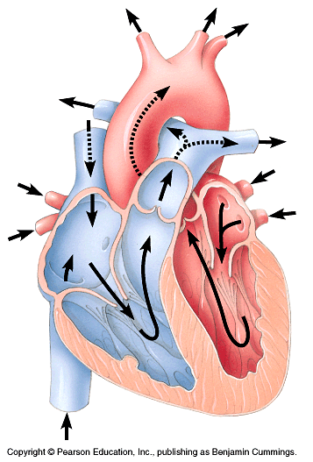

6. For each of the statements below, write the name of the structure that is being described on the blank line (some parts will be used more than once).

__________________________ the chamber that receives blood when it returns from the lungs.

__________________________ the part that keeps blood with no oxygen from mixing with blood with oxygen.

__________________________ the vessel that carries blood with oxygen from the lungs to the heart.

__________________________ the chamber that contains the pacemaker

__________________________ the largest artery in the body

__________________________ the chamber responsible for pumping blood out of the heart to the lungs.

__________________________ the chamber that receives blood when it returns from the body.

__________________________ the only vein to carry blood with oxygen.

__________________________ the vessel that carries blood to the lungs for gas exchange.

__________________________ the valve that controls the flow of blood between the atrium and the ventricle.

__________________________ the valve that controls the flow of blood between ventricles and arteries

__________________________ the vein that brings blood back to the heart from the upper body.